

PIXEL GROUP PROCCESSING

Software to teach PGP

Claude Segla

14012454

Table of Contents

Term of Reference 3

Course-Specific Learning Outcomes: after the completion of this project the following will have been learnt: 3

Project Background 3

Aim 4

Objectives 4

Problems 4

Required Resources 5

Schedule 5

Chapter 1 - Introduction 6

Chapter 2 - Principles of e learning 7

2.1 graphical content placement and contiguity 7

2.2 Modality, Speech and contiguity 7

2.3 Redundancy principle 8

2.4 Coherence principle 8

2.5 Personalization principle 9

2.6 Asynchronous learning 10

2.7 User Interface 10

Chapter 3 – Critical analysis 11

3.1 Review of original work 11

3.2 violation of contiguity principle 12

3.3 violation of the coherency principle 12

Chapter 4 - Design Statement 14

4.1 Design requirements and aim 14

Header text 14

text input 14

Button 14

Chapter 5 - Implementation 15

chapter 5.1 - Choice of language 15

5.2 frameworks 15

5.3 - Kernel Convolution Algorithm 17

Chapter 6 - Design Evaluation 21

Evaluation 21

Tools to evaluate e-learning 21

Usability lab 21

Machine vision 21

Performance evaluation 21

Results 21

Bibliography 22

# Term of Reference

Software for learning Pixel Group Processing

## Course-Specific Learning Outcomes: after the completion of this project the following will have been learnt:

1. How e-learning can be used to educate people.
2. Follow proper programming conventions such as; DOM level 2+ core specification
3. Be able to develop clean, maintainable and readable code with explanatory comments
4. Understand the technique behind how filters are applied to images by pixel group processing
5. Be able to gain new skills and research skills needed to complete a project
6. Evaluate different learning technologies and how they can be applied in your own projects
7. Use information learned from previous unit such as web and multimedia to design the web interface

## Project Background

In the modern day we can’t go a day without seeing images being displayed all around us and everyone has access to social photograph application such as Instagram, Tumblr, Flickr and thousands of others on the market. We are awash with images and most of them have filters applied to them how ever subtle the effect may be. The science behind this is pixel group processing. In pixel group processing we use a technique which uses a convolution matrix (Ludwig, J. (2007), where we take an image and apply mathematical convolution on every pixel with its neighbouring pixels weighted by a kernel matrix which could be 3x3 or whatever the developer desires. Wouldn’t pictures be just plain and boring without filters? That’s why this technique is important.

There are several reason why we may want to use a filter on an image e.g. to improve one’s appearance, photographers can use them to retouch old photos and bring them to life and many others.

In our case for computer science and more specifically computer vision (Urtasun, R. (2013)) it’s very useful to be able to have a preliminary step where we can use a convolution to get rid of noise in an image for example we could apply an edge detection convolution on our image to make it easier to recognize objects and get rid of unnecessary information (noise). Here’s an illustration that I made on Photoshop (figure a1.0).

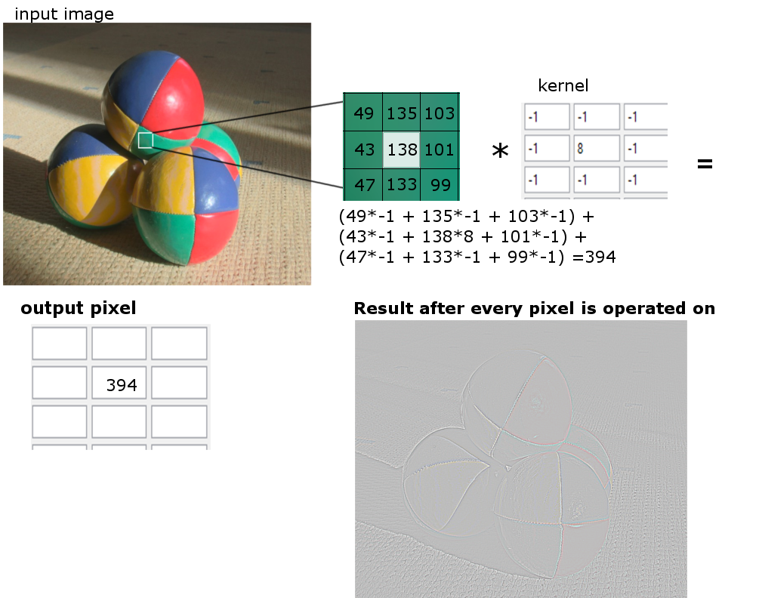

Figure a1.0

Most people have no idea about pixel group processing there I decided to do a project on it and teach it so that even a novice user or a student would be able to understand it and hopefully apply it in a project of their own.

## Aim

The aim of this project is to use existing web technologies such as JavaScript and HTML5 to re author the original application (which was written in lingo) and make a user friendly interface that can teach the discipline of pixel group processing.

## Objectives

The project objectives are as below;

* Use relevant tools (Google scholars, MMU library) to read articles and journals regarding pixel group processing
* Do some research on how people learn and best practices on e-learning
* Use Photoshop to design the web interface
* add features such as using being able to upload image and trying different convolutions on them
* Re-author the code from lingo to JavaScript
* Rigorously test the software for an bugs and fix if needed
* Give out a prototype to people and gather feedback on how much they’ve learned
* Redesign the interface depending on the feedback
* Stages you will go through to solve problem. Approach you will take to address them.

## Problems

There isn’t any major problems in particular except for edge handling. Since we have to multiply by nearest neighbours what if the current pixel is on the right edge? Then there won’t be any neighbouring pixels on the right of it. So we have to find a way to handle this. There are 3 main ways to handle this;

* Extend: that part of the kernel is skipped and not operated on
* Wrap: pixels from the opposite border will be used instead
* Crop: we just crop the pixels on the edges

## Required Resources

No additional resources needed, a computer loaded with a JavaScript and HTML5 IDE and a browser is all that’s needed.

## Schedule

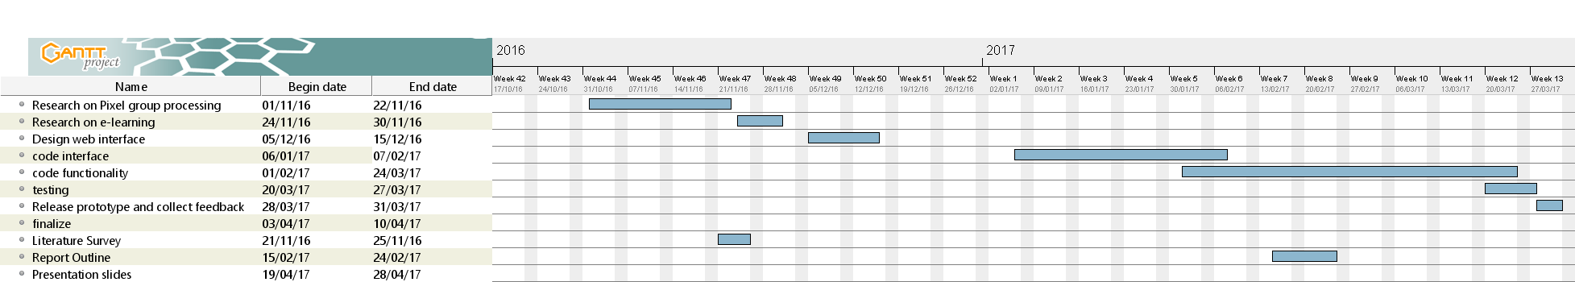

# Chapter 1 - Introduction

Image filters are applied on almost all images with or without you noticing for example colour correction, but many students don’t know how they work. pixel masks are also used heavily in image processing packages such as Photoshop for many different reasons, one of them could be for colour correction for example most cameras these days come with software to remove red eyes, that can be achieved using pixel masks. As we all know images are just encoded bits of RGB values, therefore we can edit the number to as we like. pixels are very flexible to work with as its just a matrix of numbers we can experiment with them and find out cool properties. One those techniques is known as matrix convolution, with this technique we can give special effects to images, such as Gaussian blur etc.

E Learning concerns effective use of visual and auditory senses, using multimedia content such as images, animation, videos and audio or a combination to vividly describe to the learner what they need to know about the subject matter at hand. Multimedia content developers need to be fully aware of the principles of e learning to be able to deliver the best user experience to the learner. It is theorised that humans may process information using cognitive channels, one verbal and non verbal [Mayer, 2005:34]. in contrast to Mayers hypothesis Baddeley came to a conclusion that not only do we use dual channels for processing but also they are limited in resources and both channels cannot be used to the full efficiency at any one time (Baddeley, 2001, p. 87) It’s also theorised by Mayer that humans learn through active processing of information [Mayer, 2003:45]. Those conjectures form the basis for content developer for achieving optimal learner comprehension and engagement. They also aid in defining design principles and frameworks. E learning contents are usually deployed through computers, via websites or as a computer application. E learning has become the de facto way to learn without a human tuition in the modern day as it is cost effective, flexible and is virtually accessible from everywhere (e.g. on the airplane for a business trip) .

# Chapter 2 - Principles of e learning

From the outside convolution mask seem entirely like a magic trick but actually its just a mathematical transformation of some sort. Math is an entirely abstract subject therefore its very hard for students to understand it without it being generalised in a context. Digital Images themselves are abstract, so before trying to explain convolution mask, i will be demonstrating what an digital image is composed of. We learn things easiest when its visualised to us. we also learn better when the visualisation is dynamic and interactive so they can play with it till they get the picture.

## 2.1 graphical content placement and contiguity

study shows that placement of graphical and textual components can have profound effect on the effectiveness of pedagogy. The separation of graphic and its corresponding text leads to poor performance as the learner has to switch between looking at one location to another which can cause discomfort and significantly slow down the learning process because the information retained from the graphic will somewhat be forgotten as the learner searches for the corresponding text. a better approach would be to place the text adjacent to the graphical content therefore the learner would not have to waste precious visual processing time searching for the text.

taking the contiguity approach into consideration, its imperative that we don’t obstruct the graphical content with the text as that could cause annoyance to the learner and deem counter effective. Instead wrap the text around the graphic in a readable fashion. but what if the graphic requires a large amount of space and the text simply cannot be contiguous? there are a number of ways this can be handled. as depicted by Clark and Mayer, the content can be made transformational in which the text is submerged into the graphical interface and changes overtime as different graphical elements come to attention of the learner. With the advent of HTML5 this can be easily achieved using technique such as parallax scrolling whereby the whole page is a graphical interface and the text changes as we scroll down. This will be elaborated in later chapters.

## 2.2 Modality, Speech and contiguity

The same applies for content which speech element. The interface should be made such that narrations are synchronous with the content being depicted in the graphics. Failure to do so will cause extra pressure on working memory resulting in information being spatial in the learners mind which will in turn greatly reduce comprehension and they may have to replay the audio several to fully comprehend. this claim is brought to attention by Balram and Dragicevic. Its also a good practice to replace text with speech rather than having on screen text which could distract the user from the main focus.

The effect of the modality principle is fairly insignificant for highly knowledgable students who are studying complex subjects such as maths that may have symbols or highly technical terms (mayers 1997). The speech might even slow down the progress for high performing students as they may be able to read faster. This also applies for foreign students that may not know the language very well and in cases where there may be difficulties in understanding the accent and pronunciation of complex words. in this case it would be better to use on screen text.

## 2.3 Redundancy principle

The redundancy principle discuses how having graphics, on-screen text and audio is bad practice versus just having audio and graphics [Mayer]. Sometimes situations arise whereby different formats of content delivery is needed for example being able to teach deaf people and people of poor eyesight. it might seem the only way to achieve this is by using all three methods at once, whilst we can do this due to the limited capacity assumption it would cause information overload. One way we can counter this is by only displaying the keywords in the onscreen text that way the audio is somewhat different from the text but information is not as overloaded. There has been critiques of the redundancy principle such as from Sorden who suggested that it depends on the learner and the extra information may benefit beginners whilst it would become redundant for the more experienced learner.

There are exceptional instances where we want on-screen text for a periodic amount of time for example when describing complex details such as equations, it will then be much more beneficial to have on screen text to strengthen what we mean.

## 2.4 Coherence principle

Have you ever been a lecture where the teacher had limited time to explain a complex topic and all the information just goes right over your head? Less is more is the epitome of the coherence principle (clark/ Mayer). according to Mayer content creators should avoid the use of extraneous information that may not be relevant to the current material being pursued as this would serve as a distraction and would prove challenging for the learner to stay engaged and focused. for example we should be careful in adding music to narrations as this could overshadow the narration therefore being counter active. we should also avoid seductive details that may deviate the leaners attention. Whilst the seductive detail may be graphically appealing and may aid in explaining further contents to come, we should avoid them at all times to keep the learners attention focused on the current content as beginners may not yet be advanced enough to understand the later content. so we should keep our words concise and straight forward.

[Kalyguga, 213] suggested that the coherence principle is subjective to the type of learner present. With novice learners benefiting more from the principle whilst their more experienced counter part may benefit from the extra information added.

this is perhaps one of the most important principles in e-learning but many designs simply ignore it and it can have profound effects on the effectivity of their content.

## 2.5 Personalization principle

the personalization principle dictates that using a virtual tutor and perhaps a conversational type of communication approach. engages the learner and grabs their attention which in result increases comprehension. [Mayer]. an ideal conversational approach would be one that is not overly formal as this relaxes the mood of the learner and makes the interaction more realistic to the fact that its indistinguishable from a computer.

this principle was testes by mayer in 2004 in which two identical versions of an educational game where produced one with a informal conversational style and the latter with a more formal style. This test proved mayers principle as the game with the conversional style was more favoured by the students and taught the students more than the latter. A separate study by Moreno confirms the results.

This principle also applies for spoken word as people can learn better with a natural sounding speech rather than a computerized voice which can put the students off and they not even be able to understand the pronunciations. there had been some studies done by [Naas and Brave - **year**] that proved that natural sounding narration can have profound effect on the learners ability to learn.

as we all know learning can be a stressful and boring activity but it doesn't have to be that way. in some cases it could prove beneficial to use light humour. to reduce tension and lighten up the learning experience and keep learners engaged. its important that we keep the humour to a professional level as we have to remember that the main aim is to educate and not entertain. the overuse of humour could prove counter effective and perhaps annoying especially on content that is serious.

Decorative graphics is a way we can add humour to the experience by adding some seductive detail, for example having a picture of crazy computer programmer typing code on a computer with a desk full of coffee would give the appeal of a typical computer programmers. in my case this form of humour would not be excessive and the learner may relate to it as a fellow computer science student.

## 2.6 Asynchronous learning

It is important to consider what resources the student has when using the service, therefore it’s crucial to have a way of communicating or learning. This is where asynchronous technologies come into play. Where people are not in the same location or unable to get hold of its impossible to have a synchronous communication. Therefore we must have way of obtaining the same information asynchronously. as defined by Allan Jeong ‘asynchronous technologies can be at the most basic level, defined as a tool that facilitates and mediates communication between instructors and students separated by both time and place’ (Jeong, 2015, p. 56) With the advancement of technology it is fairly feasible to achieve a level asynchronous communication such that response time is not much longer than if it was synchronous. There are a number of ways we can achieve this. One way is by email therefore it’s vital that we leave contact detail to support the learner whatever the support may be. We can also have group discussion forum for learners along with some moderators this will not only serve as a place for the learner to go for support, it could also become a place where the learner can discuss related matters and make connections with other learners. This is crucial as it greatly increases learner engagement. With the advancement of artificial intelligence we can achieve a level of synchronicity whereby we can have an AI bot that can directly answer the learner’s questions. These systems sometime prove disastrous in the case that the bot breaks a rule such as using profanity. As AI gets better so will the quality of the answers.

## 2.7 User Interface

The most important of all is the user interface, the user interface acts as an intermediary link between the content and placement of content. Therefore if we want our content to be accessed effectively we need a solid user interface that can do it justice. You could have the most accurate content yet the user won’t be able to access it properly if the user interface is poor which will result in poor compression from the user. The user interface should be designed in alignment with cognitive load theory as suggested by Adrian Taylor ‘Working memory has a limited capacity, so additional processing required by an interface can reduce knowledge transfer and retention’[Taylor, 2006:4].

# Chapter 3 – Critical analysis

In this chapter you will see an example of an e-learning environment and my critical analysis of it.

## 3.1 Review of original work

The original convolution e learning tool was made in 2005, in this chapter i will be talking about the downsides of the design and how i can improve on it.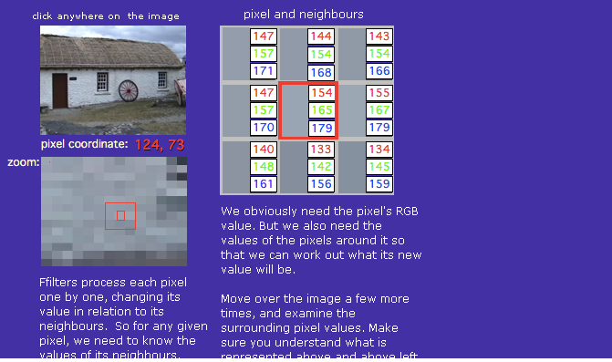

the web interface begins when the user hovers over the the image in top left corner this brings up 2 other graphic windows, the pixel and its neighbours window which is adjacent to the image as well as the image zoomed in directly below the image. text is also displayed that talks about what is going on.

one thing i noticed is that some of the text is not displayed correctly therefore the user cannot see the bottom text.

## 3.2 violation of contiguity principle

this page clearly violates the contiguity principle because the text is not contiguous with the graphics. therefore putting strain on the reader, having to look at the graphical element and to look away again to try the find the text.

we can fix this by introducing the modality principles which means we should get rid of all the text if it can fit properly across the page. instead we should add a voice over instead that way the learner can focus their visual channel on the graphical content and utilise their auditory channels.

## 3.3 violation of the coherency principle

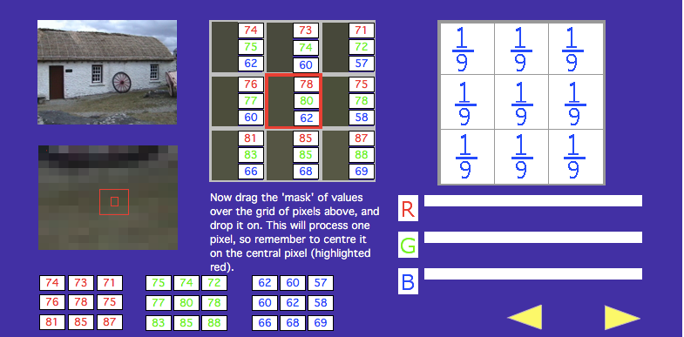

As we can from this section, it violates the coherency principle because theres simply too many distractions. we still have the original image from previous steps, i feel like its no longer needed and is only causing distraction. So we should get rid of the image or make a rollover such that the image is displayed when the user rolls over it.

over all i would say this tool could’ve been better maybe it wasn’t because of the year it designed and the limitations there could’ve been at that time, for example it could've made better use of space.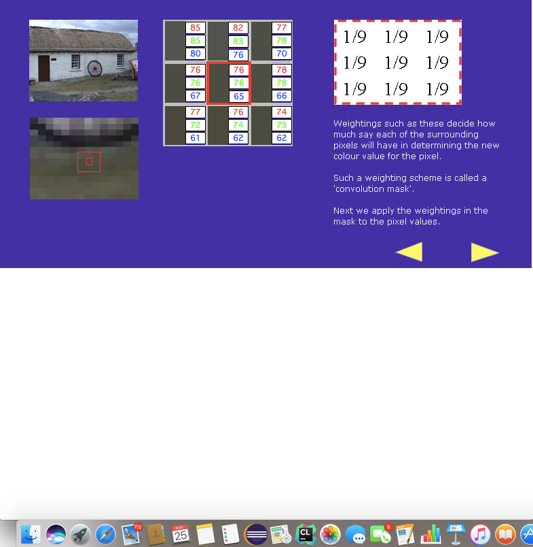

there is quite a lot of white space as you can see. i will try to avoid this in my design and make use of the full page so i can include more information. due to the small use of the page this has resulted in having very small text. which is barely readable. this will

# Chapter 4 - Design Statement

## 4.1 Design requirements and aim

I aim to accomplish the design requirement of meeting the principles of e learning by making my design clean and concise. another requirement i want to meet is that of making the content pleasing to students of all learning styles (kinaesthetic, auditory, visual ). These goals are feasible through the use of multimedia we can accommodate for all different types of students. the image below is my landing page it is this page where the user enters their name.

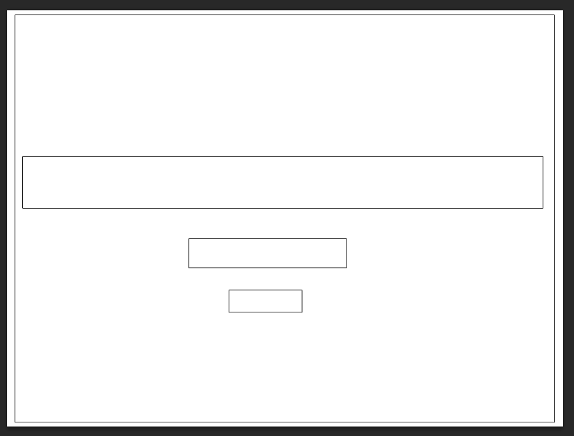

Header text

text input

Button

# Chapter 5 - Implementation

## chapter 5.1 - Choice of language

Language choice should be considered with proper thought as the whole project could take longer and become more complex if we choose an inappropriate language. Before considering the language i’m going to use, i have to consider what i want to achieve. if we know clearly what we want to achieve then language choice becomes more clearer.

The objective was to make a software for teaching pixel group processing, knowing this objective i know that i will need to have a GUI so my language of choice has to have a GUI library. Another thing i had to consider was i needed to teach people so theres going to be some text element describing the content and it needs to be accessible. it wouldn't make sense to design this in C++ or java even thought we could its these languages are not designed for that sort of thing and its not relatively portably unless compiled to an executable.

Since my application has to be heavily interactive to convey our ideas across to the learner, i thought of javascript which can be used to to make manipulations of the HTML DOM and its fairly accessible via a web browser so the learner doesn’t have to waste time downloading files and there wouldn’t be any cross platform issues.

in addition with the release of HTML5 theres lots of support for interactivity and new features such as canvas’s which i will be making use of in my project.

## 5.2 frameworks

Using a framework will allow me to streamline my production and allows me to have more freedom to think of the design rather than reinventing everything from scratch which is somewhat bad because the code is not tested as extensively as those in existing frameworks and framework libraries tend to have more optimised code meaning i can get better performance.

Since i am using javascript, i came across a javascript framework called P5.js it is essentially like the more known processing but its integrated with Javascript code. P5.js is a fairly good framework particularly aimed at Educators and artists. i choose this framework because it fits in directly with what my project is trying to achieve (educate) and i can express myself more vividly.

just to show you how easy it is to draw something onto the screen i will demonstrate a pure javascript and a P5.js equivalent.

Code

1

2

3

4

5

6

7

8

9

10

11

12

13

function setup(){

createCanvas(400,400);

backgroundcolor('red');

}

function draw(){

}

**Pure Javascript**

As you can see the P5.JS version is much more clean and declarative rather than a more imperative approach of specifying what we want to do.

1

2

3

4

5

6

7

8

9

10

11

12

13

14

15

Code

<!DOCTYPE html>

<html>

<body onload='myFunction()'>

<script>

function myFunction() {

var canvas = document.createElement("canvas");

canvas

var ctx = canvas.getContext("2d");

ctx.fillStyle = "red";

ctx.fillRect(10, 10, 400, 400);

document.body.appendChild(canvas);

}

</script>

</body>

</html>

## 5.3 - Kernel Convolution Algorithm

Design is very important in this project as the appropriate design is the only way for this project to be successful on the user end. in the following paragraphs i will be detailing over my algorithms and design choices.

First and foremost the main pixel processing algorithm will be made, this is the core of my overall project but not the most important part as it would be useless with a poor web design.

Essentially a kernel convolution is basically taking a pixel from the source image and doing some multiplication with nearest neighbours and outputting it to a target source (as illustrated in fig 1).

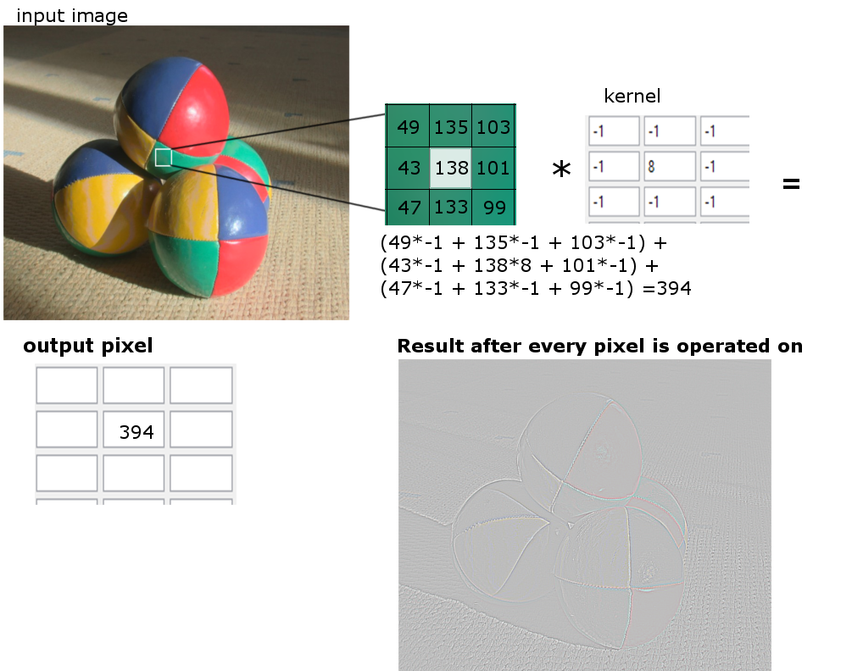

fig 1

We must output the image to a different source because if we put it back into the original image then it would cause side effects as we will be going over pixels that we just edited. my way to tackle this was to output my edited pixels to a HTML canvas that was introduced in HTML. I will be making extensive use of this element in my project.

Now that we know a little bit about pixel convolution I can describe how my algorithm works. first we have to load the image into javascript so that we have all the data we need we can use the getImageData method to get all the pixel values. once we have all the values then we can precede in the convolution algorithm once thats done we just output the new pixel data array into the output source which would be our canvas.

The pseudocode for the algorithm is as follows i will only show the Pseudocode for generating the top left nearest pixel, as its quite repetitive;

1

2

3

4

5

6

7

8

9

10

11

12

13

PseudoCode

FOR i = 0 to ImageArray.length, i = i + 4

width = width - 1

red,green,blue = i , i+1 , i+2;

TopLeftR = imageArray[reds -width]

TopLeftG = imageArray[green-width]

TopLeftB = imageArray[blue-width]

newRed = (topLeftR * 1) + (topMidR * 0) + (topRightR * -1) + (midLeftR * 0) + (middleR * 0) + (midRightR * 0) + (botLeftR * -1) + (botMidR * 0) + (botRightR * 1);

Put new red into a new imageArray

canvas.putImageData(newImageArray)

This algorithm is very simple in nature but essentially what its doing is taking the imageArray which separate each pixel sequentially by using 4 indexes for red green blue alpha (alpha is ignored in this chapter) hence why i incremented the loop by 4 every time its ran. the red would be the ith index followed by green being i+1 index, blue being i+2 index. This just wraps back round and the cycle repeats for the next pixel until we have looped out of all the array. this is great for performance because we are not checking every array so its 4 times faster than usual but i still think with tinkering or using a completely different approach, better performance can be reached.

My method of finding the neighbouring pixel is basically wrapping the index round till i get the index directly above it or whatever neighbour i’m trying to find, for example if the width of the image is 800 and i’m currently on the 1600 i could get the above pixel by subtracting 800 and i could find the bottom by adding 800. Using this approach i was able to come up with ways to find the top left, top middle, top right .e.t.c pixels.

line 7-8 is the calculation we perform to calculate the new pixels value then once we’ve calculated the red green and blue channel we can output it as a pixel then move on to the next pixel until we reach end of the loop.

# Chapter 6 - Design Evaluation

## Evaluation

Before I started this project, I set my goals out to create software to teach pixel group processing. I wanted to explore how e-learning can be used to educate people, especially in a technical context such as computer science and test how efficient it is compared to traditional methods. To achieve this feat I was to use the latest multi-media technology which are HTML5, CSS and JavaScript. I will discuss how I used these tools to achieve my goals.

### Tools to evaluate e-learning

A major benefit to evaluating e learning product Is that there are an abundance of tools that we can use, because the e learning environment is encompassed within a web browser we can write some browser plugin or software to monitor the product I will be discussing these tools.

### Usability lab

### Machine vision

### Performance evaluation

## Results

**References**

Baddeley. A.D (2001) Working Memory Still Working?

Jeong.A (2015) The SAGE Encyclopedia of Educational Technology

Kalyuga.S (2005)Beyond Knowledge: The Legacy of Competence: Meaningful Computer-based

Mayer.R (2005) *Cambridge handbook of multimedia learning* New York: Cambridge University Press.

Mayer.R/Roxanna Moreno (2003) Nine Ways to Reduce Cognitive Load in Multimedia Learning

Taylor.A(2006) Graphic Design for e-Learning Interfaces that Support Learning

# Bibliography

A.D, B., 2001. *Working Memeory Still Working?.* s.l.:s.n.